**Step1**

**Same full tree & pruned tree**

**Same accuracy=0.3597954**

tree.test.pred

0 1 2 3 4

0 0 0 55 0 62

1 0 0 512 0 395

2 0 0 676 0 537

3 0 0 518 0 470

4 0 0 330 0 942

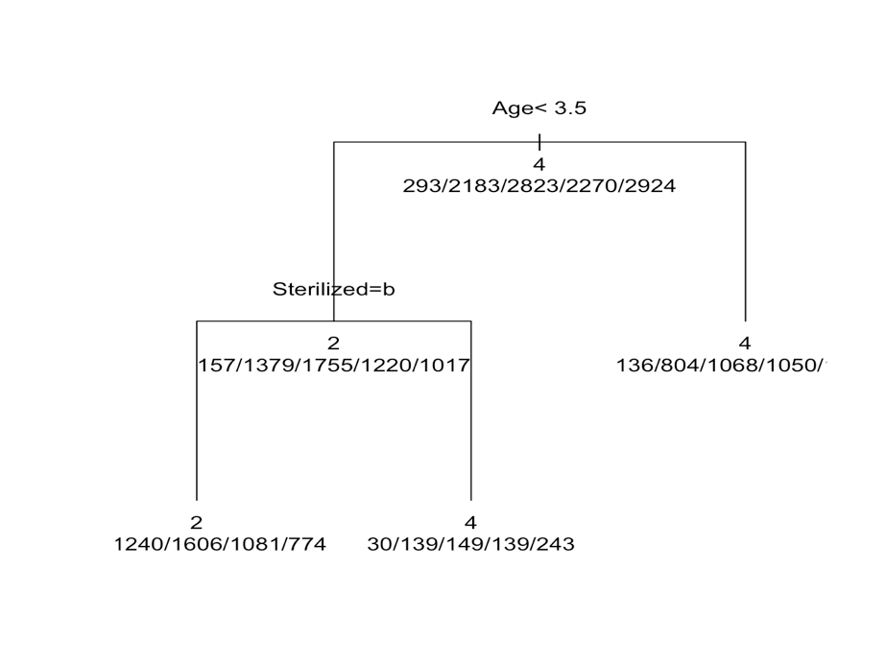

**Bagging**

**Acc=0.3884812**

pred.bag

0 1 2 3 4

0 4 37 31 11 34

1 4 289 288 100 226

2 2 232 445 208 326

3 2 163 269 255 299

4 2 155 219 142 754

**RF**

**Acc=0.4000445**

pred.rf

0 1 2 3 4

0 2 41 31 11 32

1 1 298 299 81 228

2 0 236 457 190 330

3 2 149 302 238 297

4 0 124 235 109 804

**Step 2**

**Original**

**Full tree**



tree.test.pred 0 1

0 0 0

1 1272 3225

**Pruned tree**



Table same as above

Classification tree:

tree(formula = train$adopt ~ ., data = train)

Variables actually used in tree construction:

[1] "Age"

Number of terminal nodes: 2

Residual mean deviance: 1.133 = 11890 / 10490

Misclassification error rate: 0.2787 = 2924 / 10493

Accuracy=1-0.2787=0.7213

**Bagging**

pred.bag

bag.test 0 1

0 363 909

1 294 2931

Accuracy=0.7324883

Importance:

0 1 MeanDecreaseAccuracy MeanDecreaseGini

Type 10.9177178 29.5913183 31.762585 86.40716

Age 41.9272879 88.7250560 101.642569 600.15922

Gender 0.6203405 21.5310475 20.146935 122.64779

Color1 1.1483933 24.0062560 19.714364 306.20973

Color2 0.3672724 18.9158174 15.783530 335.23394

Color3 1.8513678 13.8998759 14.228554 152.82571

MaturitySize 28.0277549 26.5640981 37.055992 118.06263

FurLength 13.6202954 22.5232641 25.931620 131.49588

Vaccinated -6.3632978 31.4205079 30.476569 114.77077

Dewormed -3.0040859 31.1667381 28.772942 113.28950

Sterilized 21.9053749 62.3113439 68.715957 134.72255

Health 8.7018255 7.5131540 11.315672 39.25287

Quantity 6.2455024 35.4824483 37.021791 184.17122

Fee 12.2875014 23.1092039 25.458649 174.93377

VideoAmt 2.3701861 0.1969159 1.277113 35.93766

PhotoAmt 37.9818303 30.1292652 47.376493 461.61155

DesLen 24.4714555 26.4775735 35.555970 1104.91834

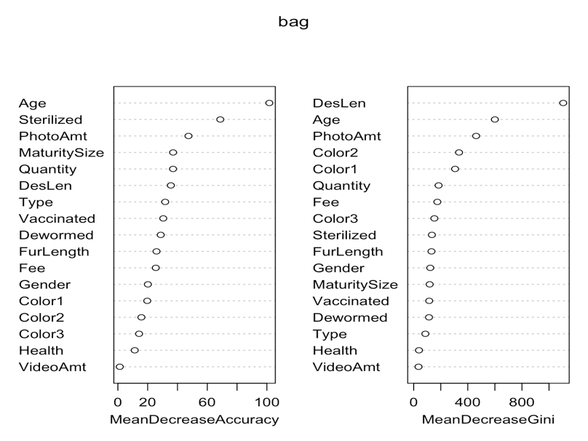

**Random forest**

pred.rf

rf.test 0 1

0 322 950

1 205 3020

Accuracy=0.7431621

0 1 MeanDecreaseAccuracy MeanDecreaseGini

Type 10.189077 26.22577283 27.513094 96.75914

Age 40.607821 79.31099329 93.534319 556.30910

Gender 7.411528 12.46044421 14.845933 137.90038

Color1 3.412962 18.05285721 17.609214 290.88377

Color2 5.209103 13.44656854 14.619896 312.95963

Color3 1.812088 9.22925871 9.551753 158.52473

MaturitySize 24.545525 20.23805384 30.845585 144.14990

FurLength 15.555032 19.32532794 24.095603 143.34165

Vaccinated -4.412707 24.05858436 24.710916 118.21883

Dewormed -6.575441 32.83557629 30.596866 119.40285

Sterilized 28.291131 42.88386170 55.668009 174.49798

Health 8.404108 7.75906803 11.720232 40.32696

Quantity 11.326868 24.05094104 29.291093 195.51365

Fee 8.570799 21.14454222 21.897216 159.74886

VideoAmt 2.093752 0.07958499 1.122430 35.67019

PhotoAmt 37.465119 20.62860744 37.058798 426.65137

DesLen 19.892177 21.63929847 28.990833 768.68071

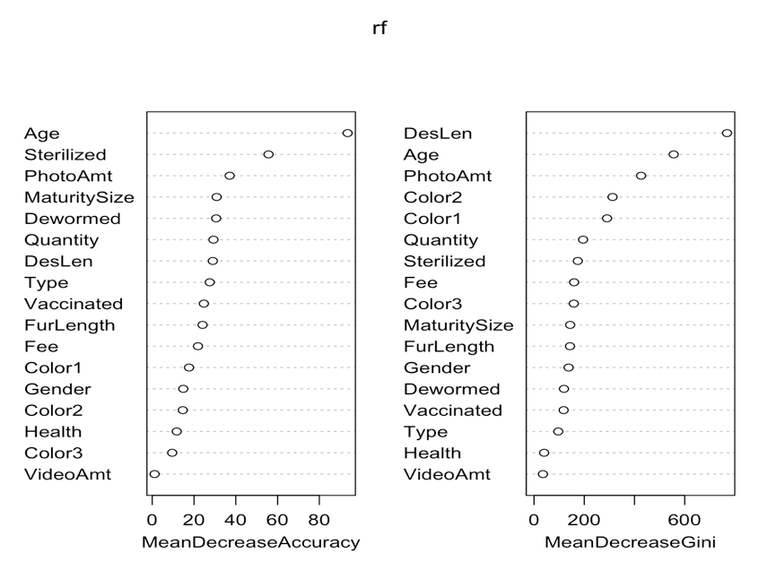

**Boosting**

var rel.inf

DesLen DesLen 24.6276051

Age Age 13.3969338

Quantity Quantity 9.6670626

Color2 Color2 9.6665586

Color1 Color1 8.9681196

PhotoAmt PhotoAmt 7.3500191

Color3 Color3 3.9766649

Sterilized Sterilized 3.9113786

Fee Fee 3.3637934

MaturitySize MaturitySize 3.2941518

FurLength FurLength 2.6909663

Gender Gender 2.5241882

Vaccinated Vaccinated 2.2787278

Dewormed Dewormed 1.8156415

Type Type 1.2522610

Health Health 0.7869256

VideoAmt VideoAmt 0.4290021



predicted

boost.test2 0 1

0 426 846

1 394 2831

Accuracy=0.7242606

**Step 3**

**Original + state**

Full tree

Same tree graph

tree.test.pred 0 1

0 0 0

1 1272 3225

Pruned tree

Same graph

Classification tree:

tree(formula = train$adopt ~ ., data = train)

Variables actually used in tree construction:

[1] "Age"

Number of terminal nodes: 2

Residual mean deviance: 1.133 = 11890 / 10490

Misclassification error rate: 0.2787 = 2924 / 10493

Accuracy=0.7213

**Bagging**

pred.bag

bag.test 0 1

0 379 893

1 273 2952

Accuracy=0.740716

0 1 MeanDecreaseAccuracy MeanDecreaseGini

Type 12.1410658 32.229320 34.662832 81.25004

Age 45.9830543 87.008311 104.733207 571.94664

Gender 2.8176406 19.458442 19.547755 109.27745

Color1 6.3013847 22.287982 23.253928 290.27823

Color2 1.0880463 21.222453 18.520390 321.45016

Color3 1.3369743 14.163792 14.107817 143.54864

MaturitySize 27.9136998 26.473186 37.914396 112.13567

FurLength 12.4850836 23.626029 26.884284 120.54813

Vaccinated -4.2467987 33.304929 32.182308 106.24727

Dewormed -5.8177859 34.165292 30.252808 99.52191

Sterilized 25.4722349 58.658875 70.670208 127.73561

Health 11.0163203 5.880767 11.402691 38.17732

Quantity 7.2968117 36.862560 37.898631 177.37856

Fee 11.3881234 24.292040 26.980733 155.32238

VideoAmt 0.7736999 -1.281318 -0.746656 34.33031

PhotoAmt 37.8435216 29.628743 47.397970 424.41724

Crime.Index.Ration.per.100.000..2017 30.6274476 21.612295 36.437583 173.98283

living.space.per.capita.sq.ft. 17.1879057 16.027133 24.304552 158.47609

DesLen 23.8220139 26.320633 36.093009 970.29802

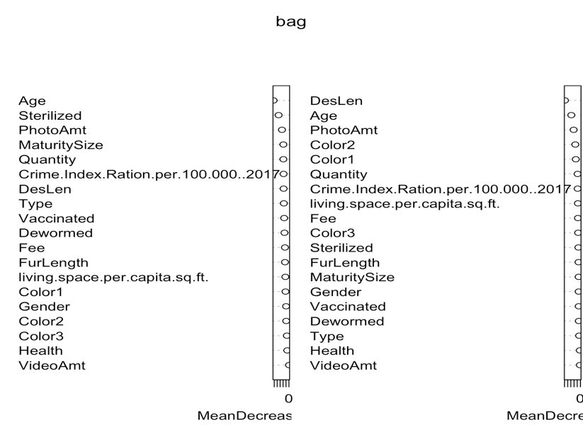

**RF**

pred.rf

rf.test 0 1

0 332 940

1 178 3047

0.7513898

0 1 MeanDecreaseAccuracy MeanDecreaseGini

Type 12.009565 25.653472 28.404130 94.12639

Age 40.622147 76.343059 90.999443 527.61532

Gender 8.962876 14.212498 18.057301 134.30897

Color1 5.038160 18.081561 19.182568 281.77031

Color2 5.126875 15.882519 17.345206 305.33892

Color3 4.169887 9.441102 10.892544 148.51883

MaturitySize 26.548081 24.638966 36.161058 140.32488

FurLength 15.731429 21.968196 27.369770 131.75433

Vaccinated -1.338144 25.394516 27.065778 113.79269

Dewormed -6.164449 30.990391 31.339492 113.91932

Sterilized 32.709052 41.407876 52.630265 169.97564

Health 9.539843 4.848213 9.241178 38.73031

Quantity 15.512873 20.602180 28.066371 192.10679

Fee 9.842244 22.927046 25.784180 143.00166

VideoAmt 2.417477 1.249941 2.435865 34.31570

PhotoAmt 37.130870 26.758309 42.069048 393.68927

Crime.Index.Ration.per.100.000..2017 13.200530 21.390077 27.254634 140.02137

living.space.per.capita.sq.ft. 17.967544 22.095487 28.633334 138.74820

DesLen 22.496950 27.197485 34.620152 678.05421

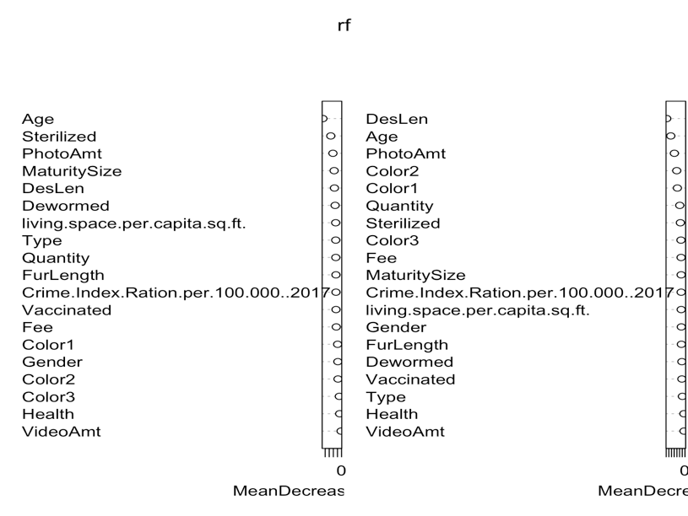

**Boosting**

var rel.inf

DesLen DesLen 22.8277697

Age Age 12.7125464

Color2 Color2 9.2074121

Quantity Quantity 9.1514475

Color1 Color1 8.4157765

PhotoAmt PhotoAmt 6.9288608

Sterilized Sterilized 3.7304618

Color3 Color3 3.7291778

living.space.per.capita.sq.ft. living.space.per.capita.sq.ft. 3.4605449

Fee Fee 3.2054535

Crime.Index.Ration.per.100.000..2017 Crime.Index.Ration.per.100.000..2017 2.9942494

MaturitySize MaturitySize 2.9186102

FurLength FurLength 2.4498567

Vaccinated Vaccinated 2.1566914

Gender Gender 2.0745452

Dewormed Dewormed 1.8355532

Type Type 1.1568768

Health Health 0.6917063

VideoAmt VideoAmt 0.3524598



predicted

boost.test2 0 1

0 450 822

1 385 2840

0.7315988

**Step 4**

Original+state+mostpopular

Full tree



Classification tree:

tree(formula = train$adopt ~ ., data = train)

Variables actually used in tree construction:

[1] "Age" "most.popular"

Number of terminal nodes: 3

Residual mean deviance: 1.112 = 11670 / 10490

Misclassification error rate: 0.2787 = 2924 / 10493

Accuracy=0.7213

Bagging

0.7480543

pred.bag

bag.test 0 1

0 440 832

1 301 2924

0 1 MeanDecreaseAccuracy MeanDecreaseGini

Type 14.2055756 32.302542 35.262660 78.11736

Age 46.7563634 104.420580 121.889941 545.71392

Gender 3.2947882 17.116255 17.551977 107.24705

Color1 3.0398759 21.696242 20.419320 282.99339

Color2 1.5140324 19.339880 17.219063 315.87306

Color3 1.5643706 12.827070 12.451135 140.83148

MaturitySize 30.1722647 26.860862 40.475570 115.59697

FurLength 8.7134933 12.224935 15.127187 107.26984

Vaccinated -0.9409409 29.280505 30.323175 102.35629

Dewormed -5.2084289 31.917559 29.835034 98.45177

Sterilized 25.1335034 71.450661 81.981963 133.07667

Health 12.5063437 6.350988 12.374999 35.69623

Quantity 9.7729588 36.129933 36.821212 174.42510

Fee 13.9157449 24.974639 29.253997 152.81186

VideoAmt 6.0283706 -1.642005 1.731992 33.03181

PhotoAmt 39.7698510 30.573945 47.685150 409.28361

Crime.Index.Ration.per.100.000..2017 10.9787746 20.472482 24.327175 107.52847

living.space.per.capita.sq.ft. 13.1672015 14.590934 19.499534 124.16926

Median.income.by.State 29.5676868 22.281527 37.584461 120.42259

most.popular 26.0430798 52.080807 58.943500 103.38051

DesLen 23.5896951 29.156529 36.776255 926.90836

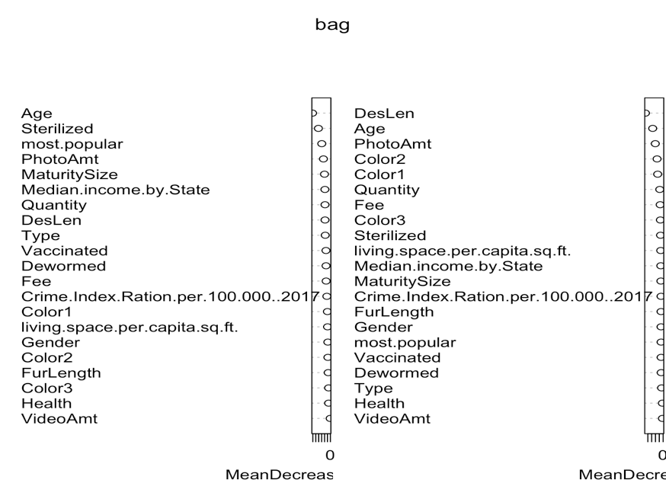

RF

0.758728

pred.rf

rf.test 0 1

0 389 883

1 202 3023

0 1 MeanDecreaseAccuracy MeanDecreaseGini

Type 13.346465 25.41190029 28.526000 92.62577

Age 40.822848 89.56193439 100.393307 531.50838

Gender 9.688107 14.08987598 18.319674 130.72566

Color1 3.987196 15.32023963 15.704281 280.24223

Color2 4.343660 15.03711478 15.421258 307.54018

Color3 3.823360 10.76938058 12.285576 147.71773

MaturitySize 27.620590 23.58487040 35.359601 136.26580

FurLength 12.032999 13.79126518 18.323303 125.43679

Vaccinated 2.502319 23.47422624 25.078351 114.09079

Dewormed -3.851439 28.86208474 27.404464 114.65780

Sterilized 27.030156 49.87000518 59.678818 167.31035

Health 8.677402 4.88021621 9.036636 36.51597

Quantity 15.542483 23.43751675 29.279756 190.72252

Fee 8.073165 24.47660708 25.269297 140.32446

VideoAmt 3.902971 -0.09490874 1.982603 33.66584

PhotoAmt 41.713758 28.39395452 47.140825 391.76626

Crime.Index.Ration.per.100.000..2017 10.956703 20.07667096 24.269774 105.41011

living.space.per.capita.sq.ft. 13.745434 20.79520165 24.353687 105.72099

Median.income.by.State 15.206145 21.15368380 25.208971 105.60731

most.popular 25.369836 37.71309797 44.036014 78.87833

DesLen 21.278044 28.48349192 35.529882 695.44753

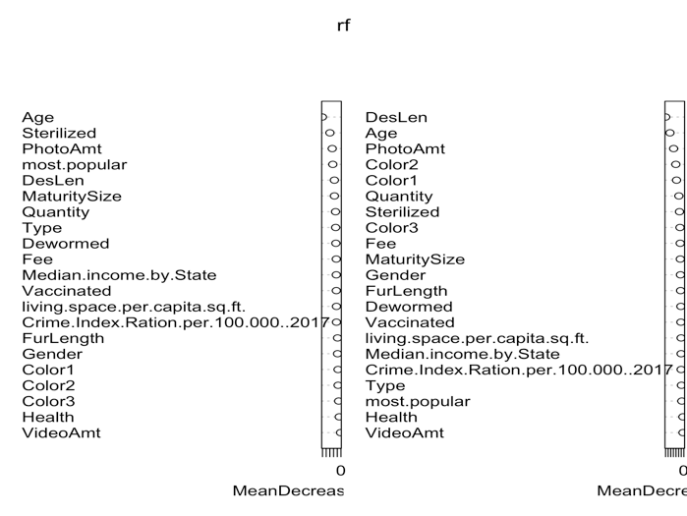

Boosting

predicted

boost.test2 0 1

0 474 798

1 409 2816

0.7315988



var rel.inf

DesLen DesLen 22.3081381

Age Age 12.4318973

Quantity Quantity 9.3505434

Color2 Color2 9.0739600

Color1 Color1 8.0658528

PhotoAmt PhotoAmt 6.7890661

Sterilized Sterilized 3.6370372

Color3 Color3 3.5996124

Fee Fee 3.1305266

MaturitySize MaturitySize 2.9200826

living.space.per.capita.sq.ft. living.space.per.capita.sq.ft. 2.8091254

Crime.Index.Ration.per.100.000..2017 Crime.Index.Ration.per.100.000..2017 2.2415150

FurLength FurLength 2.2001281

Vaccinated Vaccinated 2.0904316

Gender Gender 2.0506337

Median.income.by.State Median.income.by.State 1.8102270

Dewormed Dewormed 1.7080471

most.popular most.popular 1.6411400

Type Type 1.0909351

Health Health 0.6929317

VideoAmt VideoAmt 0.3581687

**Step 5**

Bagging

0 1 MeanDecreaseAccuracy MeanDecreaseGini

Type 13.2166450 27.843048 31.9416948 60.59933

Age 49.1107442 98.516083 115.3056175 466.06960

Gender 1.7836541 16.494209 16.6189613 80.06604

Color1 2.9115683 17.826316 16.6771430 240.84632

Color2 -0.4636810 16.943093 13.9543099 265.11901

Color3 0.8964162 12.985399 12.1174066 113.95714

MaturitySize 25.6728532 19.015277 31.9765241 93.35126

FurLength 10.5364069 9.151327 13.6862547 77.44045

Vaccinated -2.6756148 23.297929 23.6386331 76.93269

Dewormed -4.5171321 28.802841 25.7521560 75.39156

Sterilized 25.9072406 64.480259 76.0387458 120.35064

Health 11.5677868 7.342982 12.5196431 28.39145

Quantity 11.1203847 30.299717 34.4631873 156.95365

Fee 14.4679509 25.799771 30.4749323 120.99779

VideoAmt 3.6168548 -1.619114 0.5000443 25.61251

PhotoAmt 36.2904798 31.166649 45.5418506 324.45876

Crime.Index.Ration.per.100.000..2017 13.6766324 21.131531 25.8180572 89.93353

living.space.per.capita.sq.ft. 11.6932274 15.451853 19.4580448 100.78616

Median.income.by.State 24.2429713 19.661333 31.4490908 99.69705

most.popular 25.0398042 50.972577 56.2492871 99.89407

word_count -10.2474278 49.968165 50.9325600 394.56865

ave_sentiment 10.5041207 24.451397 27.5279814 615.77264

DesLen -5.1038571 53.025439 56.1687112 490.85465

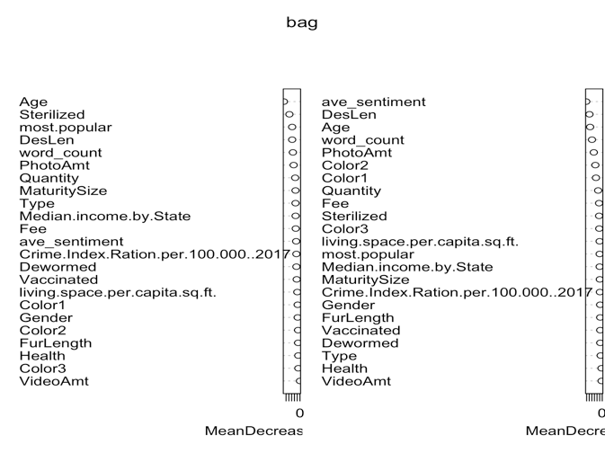

RF

0.7600623

pred.rf

rf.test 0 1

0 370 902

1 177 3048

0 1 MeanDecreaseAccuracy MeanDecreaseGini

Type 12.293278 22.3059623 25.329383 71.49978

Age 40.400019 83.9523386 97.372834 452.33136

Gender 5.060500 14.0114538 15.121520 103.28103

Color1 3.452010 14.7192811 14.445772 229.65744

Color2 3.139542 12.1819213 12.357118 259.63646

Color3 3.344173 9.6755114 10.927679 119.07006

MaturitySize 22.272379 19.1661950 29.125856 108.63157

FurLength 10.564460 13.9244352 17.225711 95.66729

Vaccinated 2.584794 21.1337740 21.837589 92.13791

Dewormed -3.993857 26.6291450 25.808922 89.21909

Sterilized 24.629127 42.5587238 49.147907 149.66979

Health 9.469312 5.0972556 10.016066 28.19565

Quantity 12.006942 21.1393335 25.525847 164.08421

Fee 8.751332 22.8129480 23.354887 110.26240

VideoAmt 3.353949 -0.8241004 1.035138 25.89211

PhotoAmt 32.548592 28.8006085 41.072425 312.94220

Crime.Index.Ration.per.100.000..2017 10.393312 18.9348581 22.707723 92.51783

living.space.per.capita.sq.ft. 12.097304 18.3887688 21.560257 91.10438

Median.income.by.State 15.766178 21.8266651 27.092899 96.11846

most.popular 25.317834 40.0639448 44.857352 71.56959

word_count -6.199834 41.7944650 44.182877 428.27052

ave_sentiment 7.983181 20.6367463 22.117722 489.58726

DesLen -5.004031 45.0155799 48.907087 472.65191

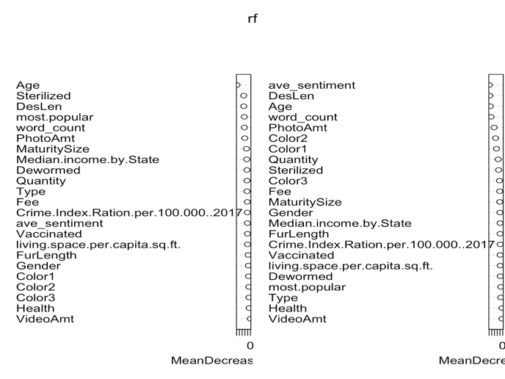

Boosting

var rel.inf

ave_sentiment ave_sentiment 17.7079755

DesLen DesLen 12.7318314

Age Age 10.1552004

word_count word_count 7.7327834

Quantity Quantity 7.4980576

Color2 Color2 7.3036608

Color1 Color1 6.7239770

PhotoAmt PhotoAmt 5.5588550

Sterilized Sterilized 2.9475085

Color3 Color3 2.5962099

MaturitySize MaturitySize 2.3126832

living.space.per.capita.sq.ft. living.space.per.capita.sq.ft. 2.3049617

Fee Fee 2.1999371

Gender Gender 1.7491610

Crime.Index.Ration.per.100.000..2017 Crime.Index.Ration.per.100.000..2017 1.5798101

Vaccinated Vaccinated 1.5395444

Median.income.by.State Median.income.by.State 1.4376725

most.popular most.popular 1.4246686

FurLength FurLength 1.4212509

Dewormed Dewormed 1.4031491

Type Type 0.9671091

Health Health 0.4655293

VideoAmt VideoAmt 0.2384635



predicted

boost.test2 0 1

0 493 779

1 399 2826

0.7380476

**Step 6**

+pet features

Bagging

pred.bag

bag.test 0 1

0 461 811

1 276 2949

0.7582833

0 1 MeanDecreaseAccuracy MeanDecreaseGini

Type 0.9290105 3.685994 5.8855864 2.70963

Age 46.6090036 111.502406 128.7930903 440.84101

Gender 3.7292824 13.607977 14.6106658 77.18544

Color1 3.0930312 17.157228 17.0087612 216.52113

Color2 2.0475962 15.977767 14.8889871 243.37309

Color3 2.2976718 10.262494 10.2646081 105.25431

MaturitySize 16.0772924 26.741593 31.5832351 82.64909

FurLength 5.1226601 10.312031 11.2495086 67.82220

Vaccinated -2.3514378 23.517468 22.7435306 74.59118

Dewormed -0.5969235 28.075745 28.0353105 73.10060

Sterilized 24.2592227 61.948616 69.2003329 132.04077

Health 9.0584989 9.389115 13.4596756 27.07536

Quantity 18.8245244 22.892874 31.2937661 163.02438

Fee 11.0996947 29.214336 30.8961808 103.96608

VideoAmt 3.7912269 -2.654433 -0.1746155 22.60540

PhotoAmt 36.5136080 31.877406 46.7756654 304.39594

Dog.Friendly 8.5219390 10.339040 12.2540407 35.58336

Easy.To.Groom 9.2704798 3.568644 11.8655856 31.50026

Easy.To.Train 9.4425359 5.743606 12.9833763 26.71673

Exercise.Needs 10.7805569 6.088295 14.6153292 31.01477

Friendly.Toward.Strangers 13.1352356 10.082267 17.2819990 45.98288

General.Health 13.2712901 11.115555 18.1438599 42.87692

Incredibly.Kid.Friendly.Dogs 4.6995904 9.533861 13.3219209 22.52879

Intelligence 8.0771520 10.431201 12.6270979 32.09987

Potential.For.Playfulness 3.1819116 10.041809 12.9797225 19.21891

Tendency.To.Bark.Or.Howl 2.2292729 8.986075 10.5714624 26.11681

life_span 11.4874298 7.577461 14.9640309 38.59607

mixbreed 7.9520120 8.165357 15.0999441 36.47020

Crime.Index.Ration.per.100.000..2017 12.8094158 22.754543 27.0578507 96.47630

living.space.per.capita.sq.ft. 11.3141641 18.907850 21.7896647 97.34557

Median.income.by.State 19.9500363 20.910832 28.4018927 97.50598

most.popular 18.9992270 23.527130 29.0526886 56.70328

word_count -1.8818873 46.566445 48.8433054 375.82396

ave_sentiment 9.5304479 21.446897 23.5918701 520.62100

DesLen 0.5054652 51.392064 55.4568497 442.61947

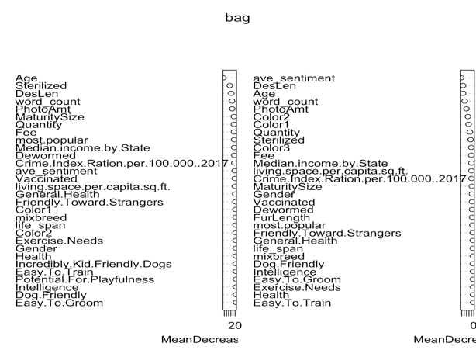

RF

pred.rf

rf.test 0 1

0 441 831

1 227 2998

0.764732

0 1 MeanDecreaseAccuracy MeanDecreaseGini

Type 3.4258408 3.41905925 6.680346 7.466645

Age 40.6826520 90.79178869 99.812650 441.485405

Gender 7.4263645 10.00271659 12.858681 95.923456

Color1 3.9640270 13.76644571 14.362054 199.869412

Color2 4.4924876 15.59141840 15.320534 225.453144

Color3 1.8607633 10.73517982 10.675591 105.738380

MaturitySize 13.8986480 21.66102959 26.276109 89.314291

FurLength 8.7734854 14.10006319 16.508160 80.279987

Vaccinated 3.0919940 23.31453018 23.535115 85.435788

Dewormed -0.1264269 27.70489134 27.867636 82.590703

Sterilized 23.3901360 42.20758049 48.691432 154.526410

Health 6.6954649 5.28068473 8.049785 27.547748

Quantity 17.1719245 16.01310357 22.456697 159.033106

Fee 5.9337878 24.91290154 24.687174 95.658286

VideoAmt 2.4071564 -0.04645885 1.367494 23.438868

PhotoAmt 31.7067807 27.25088020 40.289624 280.763269

Dog.Friendly 8.6893547 7.23479579 13.454703 30.784530

Easy.To.Groom 8.8876915 5.10066892 11.556766 30.801585

Easy.To.Train 9.9188362 4.34358968 10.766936 27.960004

Exercise.Needs 12.5504699 4.98132822 13.411141 31.045693

Friendly.Toward.Strangers 11.2865561 10.11355176 16.382858 34.486835

General.Health 14.0506109 4.25807616 14.706659 37.723984

Incredibly.Kid.Friendly.Dogs 8.6528186 7.70288730 12.639663 27.346853

Intelligence 8.5104333 5.01683908 10.614261 27.407661

Potential.For.Playfulness 6.5013062 8.51837158 13.529343 24.787212

Tendency.To.Bark.Or.Howl 5.1557441 8.14308190 11.024753 29.531820

life_span 12.8295898 6.41546992 14.724088 38.401868

mixbreed 9.7137613 3.61448549 11.756112 38.010641

Crime.Index.Ration.per.100.000..2017 10.7545933 21.99120772 25.419701 95.071320

living.space.per.capita.sq.ft. 9.0320465 22.29200217 25.103108 93.593771

Median.income.by.State 12.8912087 21.38850009 25.299035 95.524176

most.popular 12.7092100 17.10872386 21.317720 29.383513

word_count -2.0542168 39.44874753 41.730546 364.214527

ave_sentiment 11.0519332 21.23549656 23.807408 407.440497

DesLen -1.9755856 41.11558153 43.776604 398.543572

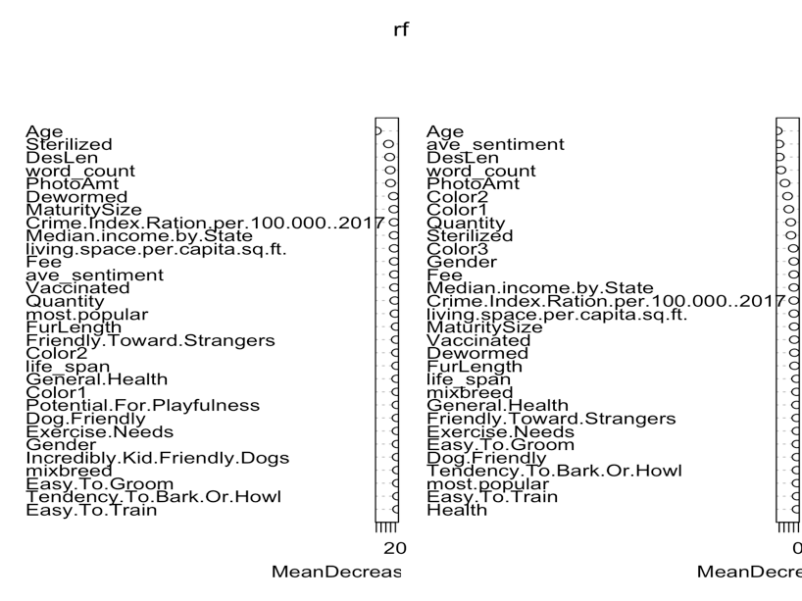

Boosting

var rel.inf

ave_sentiment ave_sentiment 16.8947797

DesLen DesLen 11.6533643

Age Age 8.9789905

Quantity Quantity 7.3400525

word_count word_count 6.9601122

Color2 Color2 6.6990054

Color1 Color1 6.0434983

PhotoAmt PhotoAmt 5.2130952

Sterilized Sterilized 2.9855275

Color3 Color3 2.5254587

living.space.per.capita.sq.ft. living.space.per.capita.sq.ft. 2.1856712

Fee Fee 1.9444486

MaturitySize MaturitySize 1.6916041

Crime.Index.Ration.per.100.000..2017 Crime.Index.Ration.per.100.000..2017 1.5504027

Vaccinated Vaccinated 1.5220527

Gender Gender 1.4392041

Median.income.by.State Median.income.by.State 1.3453677

FurLength FurLength 1.3325622

Dewormed Dewormed 1.2576439

life_span life_span 1.1437818

General.Health General.Health 0.9882460

most.popular most.popular 0.9050880

Dog.Friendly Dog.Friendly 0.8514163

Exercise.Needs Exercise.Needs 0.8129256

Easy.To.Groom Easy.To.Groom 0.6950175

Easy.To.Train Easy.To.Train 0.6810188

Friendly.Toward.Strangers Friendly.Toward.Strangers 0.6769577

Intelligence Intelligence 0.6596414

Tendency.To.Bark.Or.Howl Tendency.To.Bark.Or.Howl 0.6239371

mixbreed mixbreed 0.6107531

Incredibly.Kid.Friendly.Dogs Incredibly.Kid.Friendly.Dogs 0.5052357

Health Health 0.4809294

Potential.For.Playfulness Potential.For.Playfulness 0.3999695

VideoAmt VideoAmt 0.2949878

Type Type 0.1072528



predicted

boost.test2 0 1

0 514 758

1 400 2825

0.742495

**Step 7**

+PCA

Bagging

pred.bag

bag.test 0 1

0 463 809

1 276 2949

0.758728

0 1 MeanDecreaseAccuracy MeanDecreaseGini

Type 1.654282 6.761478 10.570994 8.17629

Age 44.462885 117.385402 133.206680 448.38596

Gender 1.575872 11.992912 11.545519 76.42598

Color1 1.218359 16.991866 15.285615 219.02265

Color2 1.541745 16.764423 15.199859 243.97694

Color3 2.211599 11.580730 12.308412 104.66279

MaturitySize 17.322108 22.118998 28.454990 83.00367

FurLength 5.977861 10.844841 12.792101 65.41274

Vaccinated -2.641871 25.424060 25.044308 71.12739

Dewormed -2.967892 28.352981 26.716281 71.95871

Sterilized 22.181883 64.239134 74.411697 123.96598

Health 8.962445 9.548824 13.217467 27.84830

Quantity 18.113487 25.780917 32.501292 162.20206

Fee 12.003845 26.322060 29.016265 107.36015

VideoAmt 3.625213 -3.322300 -1.109443 23.47320

PhotoAmt 37.126046 32.183786 46.037363 310.14205

Crime.Index.Ration.per.100.000..2017 12.216904 22.396328 25.434872 93.43035

living.space.per.capita.sq.ft. 11.740673 16.646415 20.863273 96.36907

Median.income.by.State 20.988271 19.078582 29.100879 95.37513

most.popular 19.459342 23.490713 28.933126 63.08953

PC1 8.868755 9.952313 18.014142 60.37891

PC2 16.854257 13.615905 23.364407 71.20752

PC3 6.640900 10.704557 12.473059 49.91902

PC4 11.164130 19.175568 20.305623 98.05770

PC5 9.708154 15.702877 18.155421 75.15168

word_count -6.084871 48.296907 48.708745 369.04979

ave_sentiment 10.309945 27.777645 28.242993 549.35430

DesLen -2.549230 51.174537 53.153585 445.72452

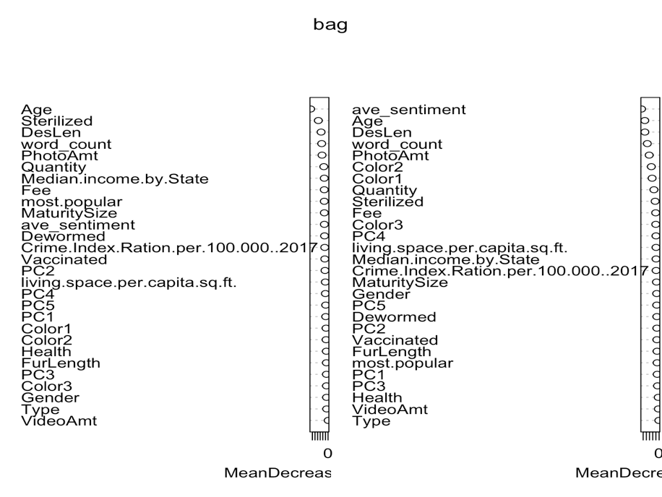

Rf

pred.rf

rf.test 0 1

0 430 842

1 216 3009

0.764732

0 1 MeanDecreaseAccuracy MeanDecreaseGini

Type 2.7142364 4.710918 7.556617 15.04766

Age 42.2680142 92.931540 105.769305 442.11917

Gender 7.3186431 9.188646 12.005393 97.63369

Color1 0.3794996 15.348335 12.986541 206.86128

Color2 2.7979231 14.340931 13.860879 231.84943

Color3 3.4713163 10.455693 11.595897 109.00310

MaturitySize 18.2580392 20.724714 27.814155 92.85539

FurLength 8.2578923 13.893333 16.436302 82.67876

Vaccinated 1.7724918 23.293292 23.542006 84.96387

Dewormed -1.9666610 26.498116 26.657604 85.02040

Sterilized 22.0683835 47.729307 51.920423 150.23197

Health 7.7264730 3.847326 7.279392 27.44522

Quantity 17.9751756 18.381767 26.018397 161.52508

Fee 6.8705785 22.954831 23.754927 97.59069

VideoAmt 3.0036309 1.857877 3.384309 23.87761

PhotoAmt 33.5646749 27.023315 40.483765 286.65341

Crime.Index.Ration.per.100.000..2017 10.9355663 21.892168 24.651963 94.95160

living.space.per.capita.sq.ft. 10.2176547 20.064491 21.715409 93.12268

Median.income.by.State 12.4054479 20.405660 24.872163 94.20897

most.popular 15.5339536 16.189102 21.521968 33.90151

PC1 13.9829911 7.928206 18.315191 67.15678

PC2 15.8534983 8.228271 19.048261 69.72824

PC3 12.0204333 11.680096 16.670124 69.18662

PC4 12.7392227 15.214782 18.790814 76.78165

PC5 12.4611459 11.790158 17.587788 77.81591

word_count -4.3208984 37.003564 40.562164 376.36761

ave_sentiment 8.6988602 20.709619 22.033712 420.64956

DesLen -2.0244188 40.138348 44.501784 409.19068

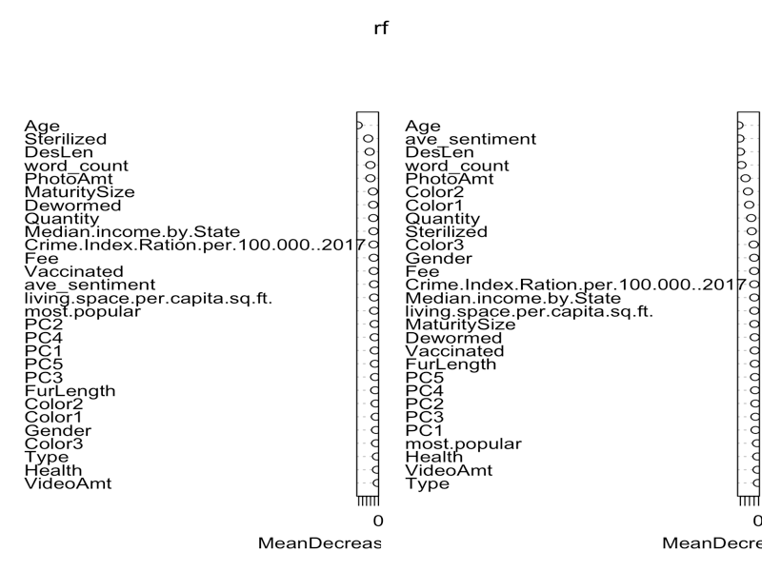

Boosting

var rel.inf

ave_sentiment ave_sentiment 16.8586038

DesLen DesLen 11.5799223

Age Age 9.0673775

Quantity Quantity 7.2446943

word_count word_count 6.8753903

Color2 Color2 6.5607014

Color1 Color1 5.9155360

PhotoAmt PhotoAmt 5.2546249

Sterilized Sterilized 3.0308855

Color3 Color3 2.5237053

PC4 PC4 2.3007547

living.space.per.capita.sq.ft. living.space.per.capita.sq.ft. 2.2207791

PC1 PC1 1.8796481

Fee Fee 1.8771195

MaturitySize MaturitySize 1.8239270

PC2 PC2 1.7002305

PC5 PC5 1.5909427

Crime.Index.Ration.per.100.000..2017 Crime.Index.Ration.per.100.000..2017 1.5526863

Gender Gender 1.5279203

PC3 PC3 1.4695016

Vaccinated Vaccinated 1.4062286

Dewormed Dewormed 1.3082501

Median.income.by.State Median.income.by.State 1.2623723

FurLength FurLength 1.2151377

most.popular most.popular 0.8682596

Health Health 0.5449396

Type Type 0.2737143

VideoAmt VideoAmt 0.2661468



predicted

boost.test2 0 1

0 519 753

1 416 2809

0.7400489